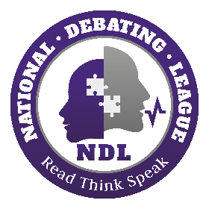

**2023 Primary Schools Debating Festival**

(Please complete digitally using Microsoft Word and return in Microsoft Word format)

Return to thishin@ndl.org.za

|  |  |
| --- | --- |
| **Speaker details** | |
| Surname: | Name(s): |
| Sex: 🗖 Male 🗖 Female |  |
| Cellphone Number: | Email: |
| School: | Grade: |
| Special Dietary Needs: 🗖 None 🗖 No beef/pork 🗖 Vegetarian | |

|  |  |
| --- | --- |
| **Parent/Guardian Contact Details** | |
| Surname: | Name: |
| Cellphone Number: | Email: |

|  |  |
| --- | --- |
| **Medical Information** | |
| Medical Aid Provider: | Medical Aid Number: |
| Relevant Medical Information: | |